PORPHYRY COPPER-GOLD MINERALISATION IN THE NEARA ARC: SPOTLIGHT ON THE BOOUBYJAN INTRUSIVE COMPLEX

Jose Veracruz^{1,2}, Paul Ashley², Nancy Vickery² and Josh Leigh¹
¹ActivEX Limited. Suite 3402, Level 34 Riverside Centre, 123 Eagle Street, Brisbane, QLD 4000
²Earth Sciences, University of New England, Armidale, NSW 2351

Keywords. Esk Basin, Neara Arc, Booubyjan, structural corridors, porphyry, supergene enrichment

Abstract
The Booubyjan porphyry Cu-(Au) deposit represents one of numerous occurrences of porphyry style Cu-Au-Mo mineralisation within the Northern New England Orogen (NNEO). It is located on the NNW-trending Early Permian to Mid Triassic Esk Basin in southeast Queensland, approximately 32km north of Goomeri. It occurs adjacent to the NNW-trending Perry Fault, and is cross-cut by the ENE-trending Darling River Lineament, which offers a favourable structural setting for the emplacement of porphyry-style mineralising intrusions such as Booubyjan and the nearby Coalstoun system. The geometry and location of some of the world’s major porphyry systems are controlled by similar arc-oblique fault systems, such as Escondida and Chuquicamata in northern Chile, and the Cadia district in New South Wales. Recognition of these regional scale oblique fault systems is of crucial importance for exploration success in porphyry belts.
The areal extent of the Esk Basin is defined by the surface exposure of the Early to Middle-Triassic Toogoolawah Group, which comprises calc-alkaline andesitic lavas and pyroclastics deposited in fluvial to subaerial environments (Neara Volcanics) and interbedded clastic sedimentary rocks (Bryden Formation) that locally underlie the volcanics, and a sandstone-dominated alluvial to lacustrine sequence (Esk Formation) overlying the volcanics. The geology of the Booubyjan area is dominated by the Mount Marcella Volcanics, composed mostly of andesitic lavas and pyroclastics with co-magmatic I-type porphyritic stocks that include diorite, quartz diorite, quartz monzodiorite, and granodiorite compositions. Hydrothermal alteration is extensive, covering an area greater than 5 km², centered on porphyritic apophyses in roughly concentric zones. The alteration assemblages are complex due to overprinting relationships, but generally grade outwards from prograde potassic (biotite-magnetite-anhydrite ± actinolite) to retrograde phyllic (quartz-sericite-pyrite-anhydrite ± pyrophyllite ± dickite), propylitic (chlorite-carbonate-gypsum ± epidote ± actinolite) and overprinting argillic (kaolinite-quartz ± smectite) types. Hypogene mineralisation consists of disseminated and vein-hosted pyrite-chalcopyrite ± bornite, and is associated with transitional potassic to phyllic alteration, typically overprinted by propylitic alteration. Hypogene grades of up to 0.3-0.6% Cu are largely structurally controlled along ENE-trending structures normal to the NNW trending Perry Fault, and hosted within the volcanic country rocks, a series of magmatic-hydrothermal breccias, and to a lesser extent, within the intrusives. At Booubyjan, copper grades have undergone a substantial increase through supergene enrichment processes, with values up to 2-2.5% Cu at shallow depths (21 to 29 m) forming a chalcocite ± covellite blanket with a thickness of 13 to 28 m.

Geological Setting
Early genetic models describe the Esk Basin as the product of transtensional strike-slip faulting with asymmetric basin fill, typical of half-grabens and most rift basins, and was originally referred to as the Esk “Trough” (e.g. Day et al., 1983; Korsch et al., 1989). More recent models, however, suggest that most of the basin fill, the Toogoolawah Group, was deposited in a foreland basin (Holcombe et al., 1997a; Campbell et al., 1999; Campbell, 2005). The Esk Basin records a period of deformation and magmatism related to plate motion at the eastern Australian margin, and evolved over three stages of formation. The initial Early Permian phase, related to extension and rifting processes (Holcombe et al., 1997a), was followed by a Middle Permian phase of passive thermal subsidence (Korsch et al., 1989). This was followed by a final stage of foreland loading during which the Late Permian to Early Triassic Toogoolawah Group was deposited in a depositional environment ranging from fluvial plain to debris aprons, confirming that the Hunter-Bowen Orogeny had exposed a fold-thrust highland (Campbell, 2005; Donchak et al., 2013).
The Toogoolawah Group comprises terrestrial andesitic, mainly volcaniclastics (Neara / Mount Marcella Volcanics), and interbedded clastic sedimentary rocks (Bryden Formation) that locally underlie the volcanics, and a sandstone-dominated alluvial to lacustrine sequence (Esk Formation) overlying the volcanics (Holcombe et al., 1997b). The Bryden and Esk Formations were deposited in alluvial fans, braided and meandering channel, floodplain, and lacustrine environments with rapid alterations in energy, whereas the Neara Volcanics records rapid deposition in fluvial to subaerial environments; detritus originated from the North D’Aguilar subprovince and contemporaneous volcanism such as the high-K calc-alkaline Mount Marcella volcanics which are dominant in the northern Esk Basin (Buck, 2008; Donchak et al., 2013). Co-magmatic intrusive rocks accompanied the eruption of the volcanic rocks within the basin. Such intrusives range in size from small apophyses (e.g. porphyritic granodiorite stocks at Booubyjan) to large batholiths (e.g. Boonara Granodiorite).
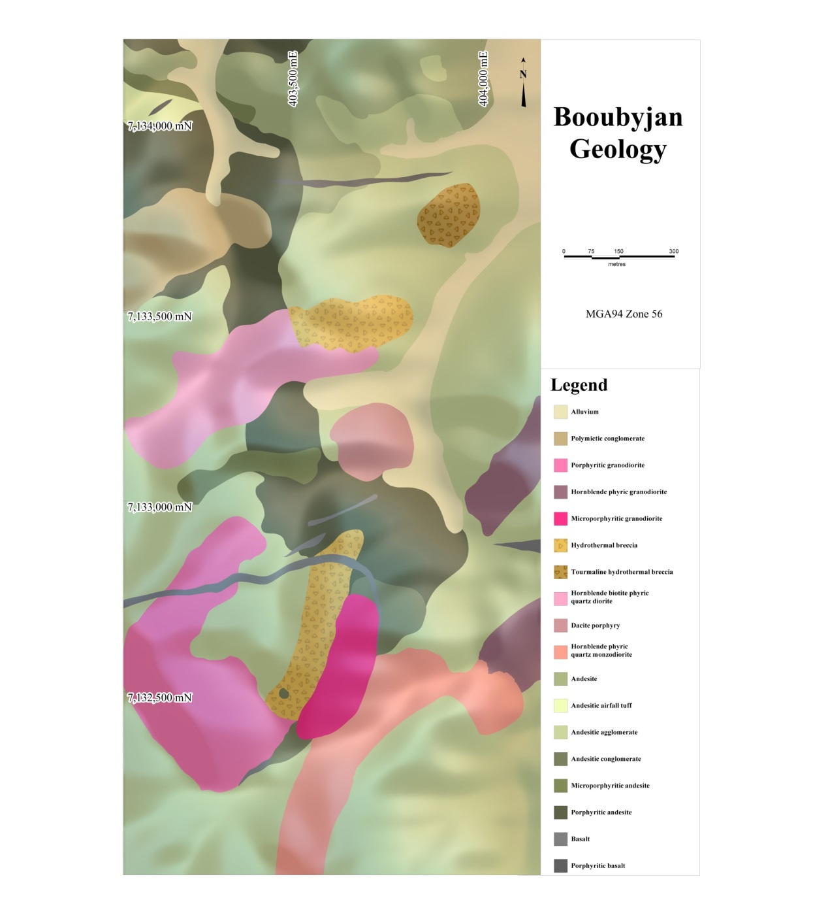
Figure 1: Simplified geology of the Booubyjan deposit.

The Booubyjan deposit (Figure 1) is hosted in andesitic to dacitic lavas, crystal-lithic tuffs, and minor conglomerate of the Mount Marcella Volcanics. These have been intruded by moderately evolved, oxidized, I-type stocks and dykes, dominated by quartz diorite and granodiorite, although there is a range in compositions to quartz monzodiorite and diorite. The variety of volcanic and intrusive porphyry rock types at the Booubyjan prospect area suggests multiple phases of calc-alkaline magmatic activity. The rapid changes of intrusive types within the relatively small prospect area infers the presence of narrow apophyses or dykes, and the textural features suggest emplacement of the intrusions to subvolcanic levels within a volcanic pile and/or small intrusions which cooled relatively quickly. The intrusives are porphyritic, with plagioclase being the most common phenocryst phase. Most intrusives also contain phenocrysts including hornblende, and less commonly, biotite. The groundmass is mostly quartzofeldspathic, fine grained and inequigranular, containing plagioclase, quartz, K-feldspar, and minor hornblende, clinopyroxene and trace apatite. Such intrusives appear to have intruded the volcanic country rocks pre-, syn-, and post-mineralisation. Multiple narrow late stage dykes have been identified both in outcrop and drilling, including basalt, andesite, hornblende-phyric andesite, and megacrystic feldspar andesite.

Mineralisation potential of the Esk Basin
Periodic variations in the distribution of important mineral deposits reflect the cyclic aggregation and breakup of accretionary orogens, and are particularly abundant in island arcs and basins along the margins of the Pacific (Barley and Groves, 1992; Bierlein et al., 2009). These include deposits formed during arc development such as porphyry and epithermal deposits (e.g., Seedorff et al., 2005; Simmons et al., 2005), and VMS deposits in extensional back-arc basins (e.g., Franklin et al., 2005). Examples of mineral deposits in the Esk Basin (fig 2) include the Booubyjan and Coalstoun porphyry deposits (Harvey, 2006; Ashley et al., 1978), the Ban Ban Zn skarn (Ashley, 1980), the Mt Rawdon breccia-hosted deposit (Brooker and Jaireth, 1995; Howard, 2015), the Mt Perry mesothermal Cu-Au deposit (Cranfield, 1994), and the Barambah low sulphidation epithermal deposit (Leigh, 2013). Porphyry Cu-Au-Mo deposits exhibit the clearest link to active subduction-accretion processes (Bierlein et al., 2009).
The greatest mineralisation episode of the NNEO in terms of variety of mineralisation styles relates to the Late Permian to Triassic (Draper, 1998), corresponding to the late stage of development of the Esk Basin and the emplacement of the Toogoolawah Group. The occurrence of Permo-Triassic porphyry-style deposits along a narrow NNW-trending belt in SE Queensland was described by Horton (1978), and significant deposits are localised by lineaments transverse to the regional structural base. These include the Booubyjan and Coalstoun porphyry deposits, related to the intersection between the ENE-trending Darling River Lineament and the Perry Fault which appear to have influenced the position of the Booubyjan and Coalstoun porphyries. O’Driscoll and Keenihan (1980) claimed that five of the largest Australian ore deposits (Broken Hill, Kambalda, Kalgoorlie, Mount Isa, and Roxby Downs), are located on continental gravity lineaments such as the Darling River Lineament. Other examples related to regional lineaments include the Escondida district, northern Chile, located at the intersection of the Archibarca lineament and the West Fissure zone (Richards et al., 2001); Chuquicamata, also in northern Chile, along the NNE-trending Mesabi Fault at its intersection with the NW-oriented Calama-Olacapato-Toro fault zone and the arc parallel N-trending Domeyko fault system (Salfity, 1985); the Oyu Tolgoi district in Mongolia, along a NNE-trending, >6.5km long, arc-oblique structural corridor (Wainwright, 2008); and the Cadia district in New South Wales, along the WNW-trending Lachlan Transverse Zone (Glen and Walshe, 1999).
Magmatic arcs typically contain arc-normal transfer structures which separate portions of subduction zones with different dips and rates of subduction (Bertrand et al., 2014). The NNW-trending Esk Basin is subdivided into a northern and a southern segment by the 15 to 20km wide Darling River Lineament, which favoured the development of dilatant features and the subsequent emplacement of mineralised porphyritic stocks. The Booubyjan porphyry deposit lies within a ~6km wide sigmoidal-shaped magnetic anomaly adjacent to the arc-parallel Perry Fault at its intersection with the arc-traverse Darling River Lineament.

.
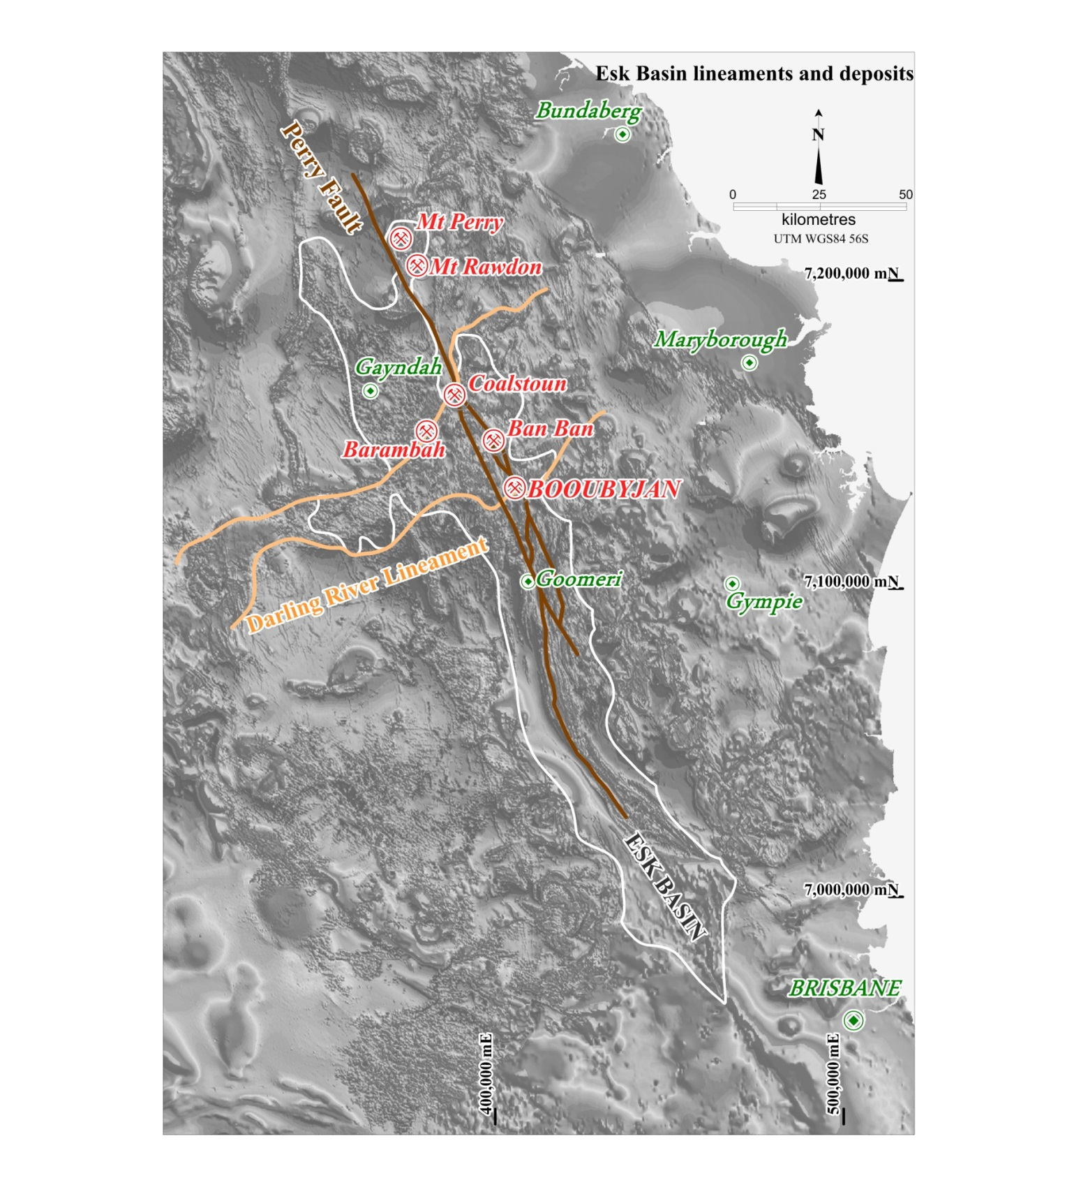Figure 2 Location of the Esk Basin in southeast Queensland, with regional magnetics on the background, and showing the relationship between mineral deposits in the basin and lineaments and faults.

Mineralisation at Booubyjan
The Early to Middle Triassic (ca 250-235Ma) was a period of widespread magmatic activity within the NNEO in southern Queensland, with abundant intermediate to felsic volcanics being erupted in north-trending rift-like structures and emplacement of genetically associated intermediate to felsic intrusives and associated hydrothermal mineral systems (Ashley et al., 1996; Draper, 1998). Porphyry style mineralisation at Booubyjan is related to Early to Middle Triassic magmatism, and is manifested as a series of porphyritic apophyses (the Booubyjan Intrusive Complex) that could emanate from a larger intrusive source at depth as suggested by a large low in regional magnetic surveys, generally termed the Goonuloom Stock.
Hypogene copper mineralisation, associated with transitional potassic-phyllic alteration and veining stage, consists of inner chalcopyrite ± bornite, which grades outward to chalcopyrite-pyrite and progressively into a pyrite halo. Copper grades of up to 0.3-0.6% tend to be proportional to vein and fracture density developed during the initial stages of alteration, and occur as mineralised clasts within magmatic-hydrothermal breccias, as fine grained disseminations within the porphyritic intrusions and the volcanic host rocks, and within quartz-magnetite stockwork and quartz-sulphide sheeted veins.
Mineralised magmatic-hydrothermal breccias are typically associated with laminated quartz-magnetite (M-type) vein fragments. M-type veins typically form at high temperatures near the core of the system, within the potassic alteration zone, and are typically related to chalcopyrite ± bornite mineralisation (Corbett and Leach, 1998). Breccias hosting M-type vein fragments at Booubyjan also contain mineralised porphyry clasts with disseminated chalcopyrite, transported by the magmatic-hydrothermal brecciation process from a Cu-rich potassic zone. Such breccias are cemented by a mixture of quartz, chalcopyrite and rock flour, and give rise to anomalously high hypogene copper grades at Booubyjan (up to 1% Cu, e.g. ABJ014 @ 223.0-224.0m). At White Horse (Figure 24), supergene oxidation increased hypogene copper values to 2-2.5% Cu at shallow depths (21 to 29m), forming a chalcocite ± covellite blanket with a thickness of 13 to 28m.
Another type of breccia at Booubyjan includes tourmaline breccia, characterised by a quartz-tourmaline ± pyrite cement, which in some Chilean deposits are important hosts to Cu(-Au) mineralisation (Sillitoe and Sawkins, 1971; Warnaars et al., 1985). Such tourmaline breccias typically form by an initial explosive venting of overpressured boron-rich volatiles, followed by a collapse stage which favours the development of sub-horizontal fractures and a final stage of fracture infill (Corbett and Leach, 1998). Tourmaline breccias may gradate downwards over hundreds of meters to biotite-cemented breccias with chalcopyrite-rich material, e.g. Los Bronces-Río Blanco (Vargas et al., 1999).
Lithic-rich pyroclastic rocks from the Mount Marcella Volcanics offer a favourable, permeable environment that may promote lateral fluid channeling and wall-rock copper mineralisation. It is likely that contrasting ferromagnesian mineral content would create redox gradients, which would favour deposition of metals from the hydrothermal fluids. In exceptionally Fe-rich country rocks, wall-rock hypogene Cu mineralisation is maximised (e.g., El Teniente, Vry et al., 2010; Oyu Tolgoi, Wainwright, 2008). Copper mineralisation at Booubyjan also occurs within sheeted vein feeders, interpreted to have formed near the top of the intrusions and transported hydrothermal fluids from the magmatic source at depth to higher crustal levels (Corbett and Leach, 1998). Sheeted quartz veins were developed close to the intrusion-wall rock contact, and were emplaced in a dilatant setting which facilitated fluid flow from the upper portions of the porphyry system (Corbett and Leach, 1998).

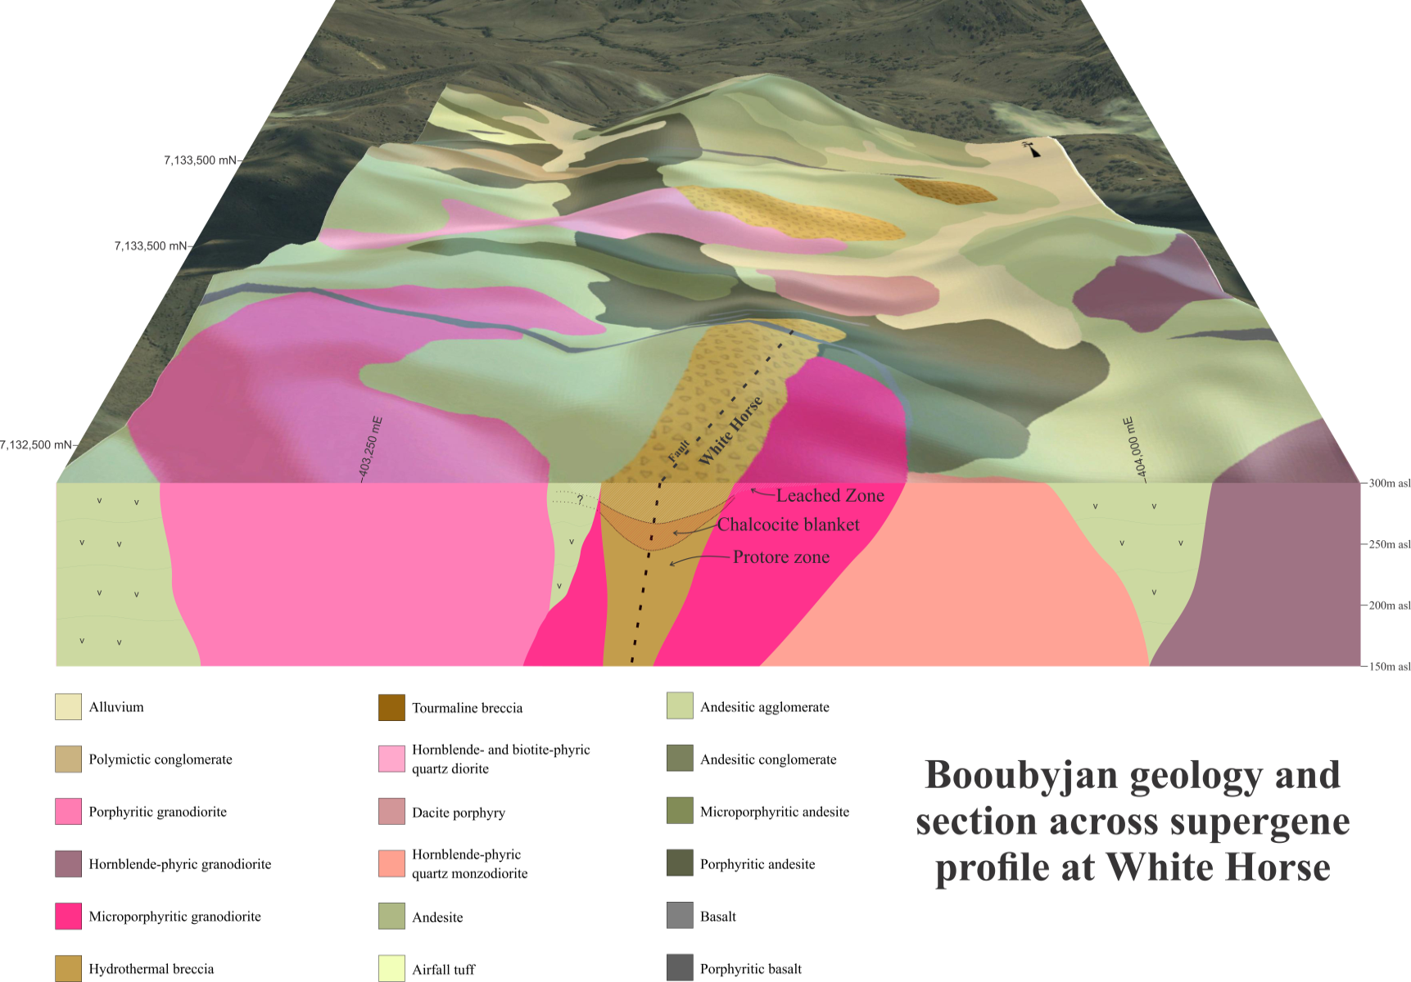

Figure 24: Section across White Horse in Booubyjan, showing the extent of the supergene profile and its relationship to local geology.

Hydrothermal alteration
Volatile exsolution, a result of the shallow-level crystallisation of the intrusives, played a critical role in the development of the Booubyjan porphyry deposit. Alteration is commonly strong and pervasive, centered on the porphyritic stocks at White Horse, although relict igneous textures are commonly moderately well preserved. The multi-stage and overprinting alteration assemblages may reflect a polyphase hydrothermal history, and is controlled by the composition of the mineralising intrusions as well as the host rock composition. Prograde potassic alteration and association mineralisation (biotite-magnetite-anhydrite ± actinolite ± pyrite ± chalcopyrite ± bornite ± molybdenite) extends from the apophyses into the country rock, and is regionally overprinted by propylitic alteration (chlorite-carbonate ± epidote) and locally by phyllic (quartz-sericite-pyrite) and argillic (clay) alteration (Ashley, 2009; 2010).
Potassic alteration is manifested in the form of fine grained hydrothermal biotite replacing former ferromagnesian phases (mainly hornblende, local biotite, and to a lesser extent, clinopyroxene in the andesitic volcanics), and commonly accompanied by hydrothermal anhydrite and disseminated magnetite ± actinolite replacing the quartzofeldspathic groundmass, with pyrite ± chalcopyrite. Potassium feldspar at Booubyjan is rare, mostly restricted to vein selvages rather than as a pervasive alteration product. The potassic alteration mineral assemblage reflects the mafic nature of the volcanic host rocks and the intrusives, and suggests that the hydrothermal fluids were relatively oxidised. Potassic alteration is most common within fragments contained in magmatic-hydrothermal breccias. Such breccias are commonly located between non-brecciated porphyry, and frequently contain pre-brecciation mineralised porphyry fragments.
Potassic alteration at Booubyjan is commonly difficult to recognise due to a strong pervasive retrograde alteration that partially to completely obscures the early alteration assemblage. Chlorite commonly overprints early formed hydrothermal biotite, but detailed petrographic observation shows chlorite pseudomorphs after hydrothermal biotite in former ferromagnesian sites, with minor sericite ± pyrite ± titanite ± rutile. Similarly, K-feldspar selvedges in veins are commonly replaced by sericite. Anhydrite, magnetite and pyrite-chalcopyrite tend to be preserved better during retrograde overprint.
Regional-scale propylitic alteration due to diagenesis / burial occurred prior to and during emplacement of the intrusives and their associated hydrothermal systems, and is the most commonly observed through Booubyjan. Feldspar phenocrysts in the porphyritic intrusions and the country volcanic rocks are replaced by pale pink hematite-dusted albite ± sericite. Chlorite, carbonate and sericite commonly replace the quartzofeldspathic groundmass, anhydrite is replaced by gypsum, magnetite by hematite, and epidote can be found peripheral to the intrusive centres. Gypsum, hematite and epidote can be found locally in high abundances, suggesting that the oxidation state of the fluids remained relatively high during retrograde alteration. The propylitic alteration mineral assemblage at Booubyjan developed at relatively low temperatures and probably from meteoric dominated fluids.
Phyllic alteration is locally important and irregularly overprints potassic and propylitic alteration, and is characterised by a quartz-sericite-pyrite assemblage. Phyllic alteration formed when the cooling intrusions exsolved acidic fluids, and is best developed at the fractured intrusion margins and within the more permeable pyroclastic volcanics. This overprint introduced abundant pyrite, which upon supergene oxidation favoured the development of leached, ferruginous outcrops at the surface, and where copper concentrations are high enough, a chalcocite blanket below. Magnetic anomalies are lowered by sericite-pyrite alteration, which in turn results in IP chargeability anomalies.
Argillic alteration, related to mixing of hydrothermal fluids with groundwaters, is represented by fine grained quartz-illite ± pyrite ± kaolinite, and in surface outcrops has substantial goethite impregnations due to destruction of pyrite. Supergene alteration is best developed in areas of sufficient pyrite content, where the intensity of leaching upon exposure to meteoric fluids is high enough to keep Cu in solution until it reaches the water table, precipitating Cu around pyrite grains in the form of chalcocite ± covellite. Supergene alteration is manifested on the surface by a mixture of kaolinite ± montmorillonite-illite and secondary silica, with jarosite, goethite and hematite after pyrite ± chalcopyrite ± bornite.
Despite the complexity of the polyphase hydrothermal alteration assemblage at Booubyjan, metal zonation patterns are evident in soil geochemistry. The mineralised core at Booubyjan, typified on the surface by supergene alteration overprinting early phyllic-potassic alteration on a magmatic-hydrothermal breccia, is irregularly shaped and extends approximately 0.8 x 0.3 km in N-NE orientation. It is likely that supergene leaching masks the original copper distribution pattern, but generally the mineralising core correlates with heavily leached potassic alteration zones characterised by an enrichment of Cu, S, K, Rb, ± Mo ± As, and depletion of Fe, Sr, Na and Ca. This is surrounded by an outer halo of elevated Pb-Zn ± Mn ± Ag extending up to 1.5 km from the intrusive centre and is related to propylitic alteration. Similarly, downhole geochemistry shows enrichment of Cu, Mo, Au, K, and S and depletions in Na and Sr over potassic altered mineralised intersections, and a clear enrichment of Zn ± Pb away from the zones of hypogene mineralisation.

Conclusion
The Booubyjan porphyry Cu-(Au) deposit, developed during the late stage of formation of the Esk Basin along the margins of Gondwana, is coeval with the emplacement of the Neara / Mount Marcella Volcanics during the Early to Middle Triassic and, which corresponds with the greatest mineralising episode of the NNEO in terms of variety of mineralisation styles. Emplaced during arc development at the intersection of the arc-parallel Perry Fault and the arc-traverse Darling River Lineament, the Booubyjan deposit in southeast Queensland offers a favourable magmatic and dilatant structural setting for the development of porphyry-style mineralisation, as is the case of world-class porphyry deposits such as Escondida and Chuquicamata in Chile, the Cadia district in New South Wales, and Oyu Tolgoi in Mongolia. Recent comprehensive geological mapping, detailed core logging and reinterpretation, recognition of magmatic-hydrothermal breccias as an important control in copper mineralisation, and unravelling of the hydrothermal alteration assemblages / mineralisation and the overprinting relationships, has greatly increased the understanding and potential of the deposit. Nevertheless, there is still a great deal to learn. The source of the mineralised porphyritic apophyses and breccias on the surface remains hidden at depth, and requires further work relative to timing of intrusion, brecciation, alteration, and mineralisation events. Detailed geological exploration on both regional and district scale, particularly the relationship between igneous evolution and mineralisation in the area, may help locate the high grade core of the system. In addition to this, further work will be required to evaluate the full potential of supergene Cu enrichment at Booubyjan.

References:
Ashley, P.M., 1980. Geology of the Ban Ban zinc deposit, a sulfide-bearing skarn, southeast Queensland, Australia. Economic Geology, 75, 15-29.
Ashley, P.M., 2009. Petrographic report on six drill core samples from the Booubyjan area, southeast Queensland. ActivEX internal report, 14p.
Ashley, P.M., 2010. Petrographic report on a suite of drill core samples from the Goonuloom Creek porphyry copper system, north of Goomeri, southeast Queensland. ActivEX internal report, 68p.
Ashley, P.M., Barnes, R.G., Golding, S.D. and Stephens, C.J., 1996. Metallogenesis related to Triassic magmatism in the New England Orogen. Geological Society of Australia, Extended Abstracts, 43, 34-42.
Ashley, P.M., Billington, W.G., Graham, R.L., and Neale, R.C., 1978. Geology of the Coalstoun porphyry copper prospect, southeast Queensland, Australia. Economic Geology, 73, 945-965.
Barley M.E. & Groves D.I., 1992. Supercontinent cycles and the distribution of metal deposits through time. Geology 20, 291-294.
Bertrand, G., Guillou-Frottier, L., and Loiselet, C., 2014. Distribution of porphyry copper deposits along the western Tethyan and Andean subduction zones: insights from a Paleotectonic approach. Ore Geology Reviews 60, 174-190.
Bierlein, F.P., Groves, D.I., and Cawood, P.A., 2009. Metallogeny of accretionary orogens – the connection between lithospheric processes and metal endowment. Ore Geology Reviews 36, 282 – 292.
Brooker, M and Jaireth, S., 1995. Mount Rawdon, southeast Queensland, Australia; a diatreme-hosted gold-silver deposit. Economic Geology 90, 1799-1817.
Buck, A., 2008. The Mt Marcella Volcanics: middle Triassic convergent margin volcanism in southeast Queensland. MSc thesis, Queensland University of Technology, Brisbane (unpublished).
Campbell, L.M., Holcombe, R.J., and Fielding, C.R., 1999. The Esk Basin – a Triassic foreland basin within the northern New England Orogen. In: Flood P.G. (Ed.) New England Orogen: regional geology, tectonics and metallogenesis – 1999 conference papers, University of New England, 275 – 284.
Campbell, L.M., 2005. Basin analysis and tectonic evolution of the Esk Trough in southeast Queensland. PhD thesis, University of Queensland, Brisbane (unpublished).
Corbett, G.J., and Leach, T.M., 1998. Southwest Pacific gold-copper systems: structure, alteration and mineralisation. Special Publication 6, Society of Economic Geologists, 238p.
Cranfield, L.C., 1994. Maryborough, Queensland sheet SG56-6. 1: 250 000 geological series – explanatory notes. Geological Survey of Queensland, Brisbane, 120p.
Day, R.W., Whitaker, W.G., Murray, C.G., Wilson, I.H. and Grimes, K.G., 1983. Queensland geology. A companion volume to the 1:2500000 scale geological map (1975). Geological Survey of Queensland Publication 383, 194p.
Donchak, P.J.T., Purdy, D.J., Withnall, I.W., Blake, P.R., and Jell, P.A., 2013. New England Orogen. In: Jell, P. (Ed.) Geology of Queensland, Geological Survey of Queensland, 305 – 472.
Draper, J.J., 1998. An overview of post-Mesoproterozoic mineralisation in Queensland. AGSO Journal of Australian Geology & Geophysics, 17(3), 61-73.
Glen, R.A. and Walshe, J.L., 1999. Cross structures in the Lachlan Orogen: the Lachlan Transverse Zone example. Australian Journal of Earth Sciences, 46, 641-658.
Harvey, J., 2006. Copper-gold mineralisation at Booubyjan project, southeast Queensland. BSc Honours thesis, University of Queensland, Brisbane (unpublished).
Holcombe, R.J., Stephens, C.J., Fielding, C.R., Gust, D., Little, T.A., Sliwa, R., Kassan, J., McPhie, J., and Ewart, A., 1997a. Tectonic evolution of the northern New England Fold Belt: the Permian-Triassic Hunter-Bowen event. In: Ashley P.M. and Flood P.G. eds. Tectonics and metallogenesis of the New England Orogen. Geological Society of Australia Special Publication 19, 52-65.
Holcombe, R.J., Stephens, C.J., Fielding, C.R., Gust, D., Little, T.A., Sliwa, R., McPhie, J., and Ewart, A., 1997b. Tectonic evolution of the northern New England Fold Belt: Carboniferous to early Permian transition from active accretion to extension. In: Ashley P.M. and Flood P.G. eds. Tectonics and metallogenesis of the New England Orogen. Geological Society of Australia Special Publication 19, 66-79.
Horton, D.J., 1978. Porphyry-type copper-molybdenum mineralisation belts in eastern Queensland, Australia. Economic Geology, 73, 904-921.
Howard, N. 2015. Geochemistry and hydrothermal alteration at the Mount Rawdon gold deposit. New England Orogen geology, tectonics, economics. Australian Institute of Geoscientists seminar series, Brisbane, June 5, 2015.
Korsch, R.J., O’Brien, P.E., Sexton, M.J., Wake-Dyster, K.D., and Wells, A.T., 1989. Development of Mesozoic transtensional basins in easternmost Australia. Australian Journal of Earth Sciences 36, 13-28.
Leigh, J.J. 2013. The geology and geochemistry of the Barambah gold-silver deposit. BSc Honours thesis, University of New England, Armidale (unpublished).
O'Driscoll, E.S.T., Keenihan, S.L. 1980. The Toowoomba-Charleville lineament in southern Queensland. APEA Journal 20(1), 16-24
Richards, J.P., Boyce, A.J., and Pringle, M.S., 2001. Geologic evolution of the Escondida Area, northern Chile: a model for spatial and temporal localization of porphyry Cu mineralisation. Economic Geology, 96, 271-305.
Salfity, J.A., 1985. Lineamientos transversales al rumbo andino en el noroeste Argentino. Congreso geológico Chileno, NO.4, Actas 2, 119-127.
Seedorff, E., Dilles, J.H., Proffett Jr, J.M., Einaudi, M.T., Zurcher, L., Stavast, W.J.A., Johnson, D.A., and Barton, M.D., 2005. Porphyry deposits: characteristics and origin of hypogene features. Economic Geology 100th Anniversary Volume, 251-298.
Simmons, S. F., White, N. C. and John, D., 2005, Geological characteristics of epithermal precious and base metal deposits: Economic Geology 100th Anniversary Volume, 485-522.
Vargas, R., Gustafson, L.B., Vukasovic, M., Tidy, E., and Skewes, M.A., 1999, Ore breccias in the Rio Blanco-Los Bronces porphyry copper deposit, Chile: Society of Economic Geologists Special Publication 7, 281−297.
Vry, V.H., Wilkinson, J.J., Seguel, J. and Millán, J., 2010. Multistage intrusion, brecciation, and veining at El Teniente, Chile: evolution of a nested porphyry system. Economic Geology, 105, 119-153.
Wainwright, A.J., 2008. Volcanostratigraphic framework and magmatic evolution of the Oyu Tolgoi porphyry Cu-Au district, south Mongolia. PhD thesis, University of British Columbia, Vancouver (unpublished).
Warnaars, F.W., Holmgren, C. and Barassi, S., 1985. Porphyry copper and tourmaline breccias at Los Bronces-Río Blanco, Chile. Economic Geology, 80, 1544-1565.

